|  |  |
| --- | --- |
|  | Low-Temperature Oxidation and Spontaneous Combustion Tendency of Blended Coal between Anthracite and Sub-Bituminous Pulverized Coals |
| Duc Dung Le1,Viet Thieu Trinh1,*, and Huu Linh Nguyen1 |

|  |  |  |
| --- | --- | --- |
| A R T I C L E I N F O  Article history:  Received: 22 December 2020  Revised: 31 January 2021  Accepted: 15 February 2021  *Keywords*:  Low-temperature oxidation  Blended coal  Spontaneous combustion |  | A B S T R A C T  In this study, the thermogravimetric analysis (TGA) and basket method are used to evaluate the oxidation at low temperature and forecast the self-heating propensity of five blended pulverized coals with the sub-bituminous ratios of 0, 25, 50, 75 and 100% in anthracite coal. The results obtained from TGA curves that the self-oxidation potential at low temperature could be predicted by the detection of the mass gain during the early stage of heating. The basket method for spontaneous ignition is conducted, which determines the critical ignition temperature. The results show that the greater coal pile volume, the lower the critical temperature combustion. In addition, spontaneous combustion is more likely with the high sub-bituminous coal ratio. Thus, it is essential to be conscious of monitoring the spontaneous combustion of the coal pulverizer system in the actual operation of burning with sub-bituminous coal in anthracite coal-fired boilers. |

* 1. INTRODUCTION

The explosions relating to coal's self-ignition are of interest in several thermal power plant operation areas. Self-heating of finely pulverized coal particle deposits in corners and other dead regions could be a potential ignition source for an explosion. Although there were some efforts in preventing spontaneous combustion occurring, some explosions were believed to have been caused by self-heating of deposited coal in siloes or mills that ignited coal dust resulting in a massive explosion [1], [2].

In Vietnam, sub-bituminous coal with unknown histories is now being imported to co-firing with domestic anthracite coals as an alternative solution to adapt the future power and coal demand for power generating facilities outlook up to 2030. However, because of its high reactivity, such coal is more prone to self-ignition, lowering its heating value and degrading its quality. Thus, early detection and prevention of spontaneous ignition are a greater role of thermal power plants. Although some efforts were made to prevent spontaneous combustion occurring, there were some explosions believed to have started by spontaneous ignition of coal in silos and pulverizes at coal-fired plants [3].

The balance between heat generation from the exothermic oxidation reaction and heat dissipation to the surrounding is the primary source of heat release resulting from self-heating at low-temperature in storage coal  [4], [5]. If the generated heat is greater than the dissipated heat, spontaneous ignition will be likely to occur. Several laboratory studies have been conducted to verify and predict the self-ignition of coal piles. T.X. Ren et al. [4] used adiabatic oxidation method to evaluate the spontaneous combustion tendency of 18 pulverized coals. Y.S. Nugroho et al. [6] examined the influence of coal physical structure and particle size on the self-heating character of blending high and low rank coals utilizing the crossing point technique in a basket. Xiaowei Zhai et al [7] studied the kinetics of blended coals to predict the spontaneous combustion tendency through the method of thermogravimetric analysis (TGA). Claudio Avila et al. [8] presented the spontaneous ignition of coal using TGA. Y. Wang et al. [9] used the basket method to determine critical spontaneous combustion temperature of high volatile coal and extrapolate to industrial coal piles. These lab studies demonstrated that the spontaneous combustion propensity of coal piles could be predicted using laboratory tests.

In this paper, the TGA and the basket method is applied to evaluate the oxidation at low temperature and the propensity of self-ignition of blending of pulverized anthracite and sub-bituminous coals.  Furthermore, the experiment is designed to demonstrate the impact of different sub-bituminous coal mix ratios on the critical self-ignition temperature.

* 1. MATERIALS AND METHODS

***2.1. Sample preparation***

The anthracite coal (Coal A) and sub-bituminous coal (Coal B) were selected. Their properties show quite large differences, as shown in Table 1. Coal A is typical coal used in thermal power plants in northern areas in Vietnam. Coal B was imported from Indonesia. The coal samples were ground into small grains (between 0.045 – 0.075 mm in size) which were used for this study. Sub-bituminous coal is heated at 105-110°C until a constant weight to reduce the moisture content to under 5%.

**Table 1. Properties of coal samples**

|  |  |  |
| --- | --- | --- |
| **Sample** | **Coal A** | **Coal B** |
| Moisture (wt%, as received) | 1.8 | 32.5 |
| **Proximate analysis (wt%, dry)** | | |
| Volatile matter (VM) | 11.32 | 55.96 |
| Fixed carbon (FC) | 61.12 | 31.24 |
| Moisture (M) | 1.80 | 4.80 |
| Ash (A) | 25.76 | 8.00 |
| **Ultimate analysis (wt%, daf)** | | |
| Carbon | 90.57 | 70.96 |
| Hydrogen | 3.06 | 5.13 |
| Oxygen | 4.15 | 22.51 |
| Nitrogen | 1.37 | 1.01 |
| Sulfur | 0.85 | 0.39 |
| **Heating value (kcal/kg, as received)** | | |
| HHV | 6071.2 | 6013.61 |

The tag of blended coals is presented in Table 2. There are five blended ratios of anthracite coal with the sub-bituminous of 0, 25, 50, 75 and 100%.

**Table 2. Tag of blended coal**

|  |  |  |
| --- | --- | --- |
| **Sample number** | **Coal A (%wt)** | **Coal B (%wt)** |
| No.1 | 100 | 0 |
| No.2 | 75 | 25 |
| No.3 | 50 | 50 |
| No.4 | 25 | 75 |
| No.5 | 0 | 100 |

***2.2. Low temperature oxidation experiments***

Thermo-gravimetric analysis (TGA) of the coal oxidation at low temperature (30 – 500oC) is performed using the Macro-TG (MTG). The configuration and working principle of the MTG is illustrated in Fig.1. The reactor consists of a ceramic tube (1), with 7.5 cm of internal diameter and length of 111 cm, (4) placed on a microbalance inside an electrical furnace (2). In addition, the gas flowing into the reactor is controlled by a mass flow controller, and gas emission out of the reactor by an extractor (6). The gas flowing is firstly preheated in a heating coil (3) before entering the reactor. A sample holder (4) is connected with the scale to measure the weight loss of the sample [10].

About 400 mg of each coal sample is heated from ambient temperature to 300 oC with the constant heating rate (3 oC/min) under air environment  (100 ml/min). Sample mass is measured and recorded continuously. The TG results of coal oxidation are analyzed to evaluate the influence of sub-bituminous coal ratio on the weight loss of samples due to chemical reactions and change in structure.

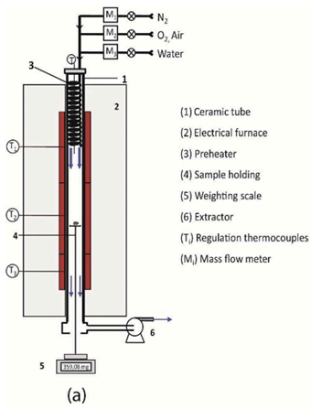

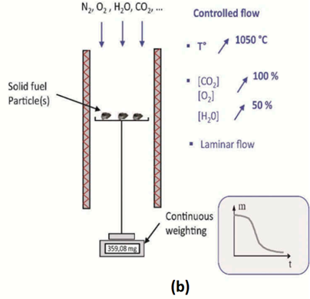

**Fig. 1. (a) Macro-TG reactor and (b) its principle.**

***2.3. Spontaneous combustion experiments***

When the temperature of the furnace increases to the preset temperature, the coal temperature rises steadily and eventually exceeds the furnace temperature due to self-ignition. If the generated heat due to exothermic internal chemical reactions is larger than that dissipated from it, then there is a rapid acceleration to high temperature and spontaneous combustion is likely to occur as illustrated in Figure 2. In this figure, the zero time of these plots are the moment of reaching ambient temperature (tE). As can be observed that the center temperature of the coal sample increased for a while with a smooth gradient and reached its peak at ΔTmax = 25 oC and then started to decrease back to preset temperature when tE = 160 oC. As a result, spontaneous combustion did not occur. In contrast, tE is 170 oC shows quite a different trend. The temperature of the sample’s center rose steadily and reached thermal runaway in just a very short time [11].

Fig. 3 presents the diagram of spontaneous combustion experiment. The samples were charged in a cube mesh basket and loaded into the programmable muffle furnace Nabertherm at room temperature. The furnace was then rapidly heated to a preset temperature at a heating rate of 20 oC /min. Air enters the furnace through natural convection flow. Three K-type thermocouples are inserted at three positions to monitor internal temperatures of the furnace and samples as shown in Fig.3 to monitor the reaction occurring inside the sample. During each experiment, a data acquisition system was used to automatically record temperature [8], [12].

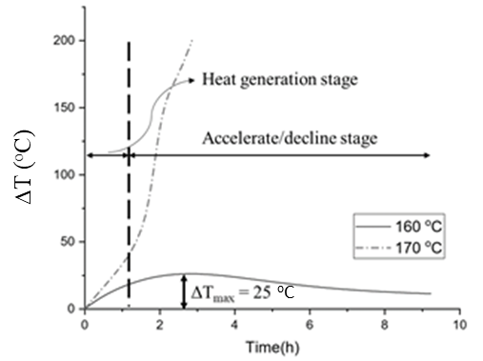

**Fig. 2. An illustration of temperature transient at the center of coal A sample at two furnace temperatures.**

The critical ambient temperature for spontaneous combustion for each sample, tc, is determined via an interactive process by varying the furnace temperature (ambient temperature, tE) with an interval of 10oC. The series of experiments is rerun with a new sample at a higher temperature if a thermal runaway does not occur (subcritical); or at a lower ambient temperature if spontaneous combustion occurs at the first experiment (supercritical). Supercritical conditions are defined as those where ignition occurs whilst subcritical conditions are those that lead to no ignition. The spontaneous combustion temperature (tc) is taken as the mean of the first supercritical temperature and last subcritical [8].

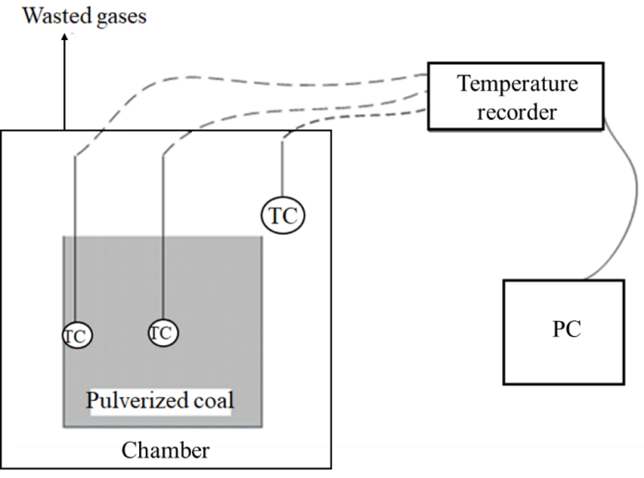

**Fig. 3. Schematic diagram of spontaneous combustion.**

A series of experiments is conducted for three different pre-shaped baskets as listed in Table 3. The tc is determined depending on the basket size. From this experiment data, it is used to evaluate a safe volume of fuel piles in practice by means of the Frank-Kamenetskii model.

Pulverized coal is placed in the different sized cube boxes (Table3) that are made from alumina grid. Spontaneous combustion test was carried out for various coals to obtain the temperature transition of the coal layer. Before the test, the pulverized coal was not preheated.

Coal layer temperature sensor is measured at the center and at the outside under varying conditions of ambient temperature, pulverized coal layer thickness and coal mass-mixing ratio. The reactor is filled with pulverized coal and is heated rapidly at the heating rate of 20 oC/min from room temperature to the setpoint temperature in the range of 90oC to 200oC [5], [9].

**Table 3. The dimensions of baskets (unit: mm)**

|  |  |  |  |
| --- | --- | --- | --- |
| **Basket** | **Height (H)** | **Length (L)** | **Width (W)** |
| B-1 | 30 | 30 | 30 |
| B-2 | 60 | 60 | 60 |
| B-3 | 100 | 100 | 100 |

* 1. RESULTS AND DISCUSSION

***3.1. Low temperature oxidation characteristics of coal***

Fig. 4 shows the TG curves of samples during the oxidation process. As could be observed from Fig. 4, the TG curves present different thermogravimetric profiles. For anthracite coal (coal A) indicates a positive weight increase, where the characteristic weight gain is detected. Over the temperature range of 100 – 400 oC, the weight of coal A increases by 2%, but other samples (No.2 – No.5) do not show a mass gain in Fig. 4. The oxygen adsorption resulting in the development of carbon-oxygen complexes on the coal surface is the most widely accepted process for explaining mass increase at low temperatures.

The thermal decomposition of coal A, which is classed as low-reactive coal based on the amount of mass response during sample heating, begins at a significantly higher temperature and reacts more slowly than highly reactive coal B. It is because the coal A has a substantially lower volatile percentage than coal B. (11.32 percent compared to 58.96 percent as presented in Table 1). This could also be attributable to the durability of the solid complexes generated. With higher peak temperatures at which the weight gain is greatest, samples that produce stable solids exhibit greater weight increases. Samples that produce less unstable and/or unstable solids, on the other hand, desorb at lower temperatures and exhibit no mass increase. Furthermore, as can also be seen from Fig 4 that the samples with a zero-weight gain show comparative devolatilization rates that increase with the increase of blended ratio of coal B in the mixture. This might be linked to the more unstable solid complex generation during the early stages of heating with a larger proportion of coal B, which promotes the release of volatile matter and results in a lower ignition temperature [13], [14].

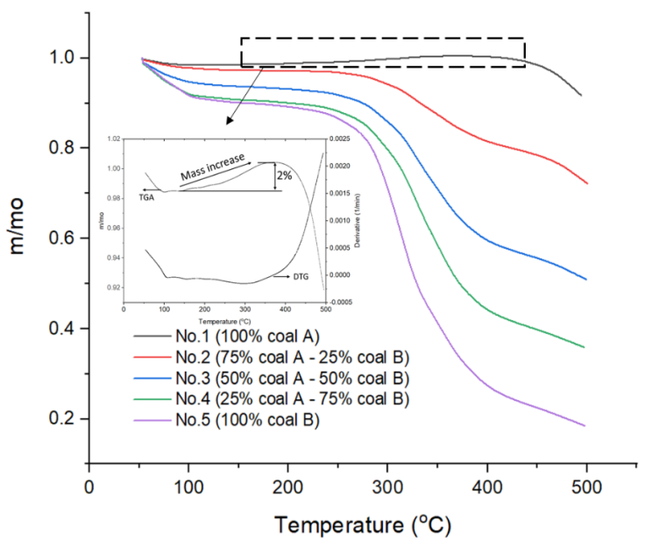

**Fig. 4. TGA curves of coal A, coal B and their blends.**

***3.2. Spontaneous combustion of the blended coal***

*3.2.1. Self-heating phenomena of single coal*

Figure 5 and Figure 6 illustrate the typical spontaneous combustion phenomena of single coal of B-1 basket. In Figure 5, spontaneous ignition of coal A needs an ambient temperature over around 170oC for basket thickness 30mm. As a result in Figure 6 spontaneous combustion happens when ambient temperature is around 110oC for coal B. Coal B with more volatile matter is easier on lower environment temperature than that of coal A, 55.96% compared with 11.32%.

It is clearly observed in Figure 5a and Figure 6a the temperature of coal increases and reaches at a slightly higher temperature level compared to the furnace temperature due to self-heating and then slightly declines, staying almost constant for about 15 hour of coal A and 25 hour for coal B. The rate of heat production from oxidation is now properly balanced with the heat dissipation rate.



1. Sub-critical



(b) Supercritical

**Fig. 5. Temperature profiles of Coal A of sample No.1.**

As shown in Figure 5b and 6b, the coal spontaneous combustion process is done in two stages. The first stage is the heat of the conduction process or called sub-critical and the second stage is supercritical whilst supercritical conditions are those that lead to ignition. Coal A having a shorter time to reach ignition compared with coal B. Coal A takes about 4 hour to ignite, while coal B is observed around 13 hour to ignite. It might be explained by coal A has higher ambient temperature than coal B. The heat conduction of coal A is greater than that of coal B at higher ambient temperatures.

Figure 5b and Figure 6b show that after reaching the preset temperature of the furnace the temperature in the coal bed continues to rise until it self-ignites. Whether in sub-critical or supercritical conditions, the central temperature rises above the surface temperature in all runs. It is suggested that the ignition of coal begins from the center of the stockpile and spreads to the entire coal mass.



1. **Sub-critical**



**(b) Supercritical**

**Fig 6. Temperature profiles of Coal B of sample No.1.**

*3.2.2. Effect of blending ratio on critical temperature*

Figure 7 presents the influence of sub-bituminous coal (coal B) ratio in the mixture under three different baskets to the critical temperature, tc, of coal samples. The figure shows an overall trend that lower tc were observed in the case of higher proportion of coal B. In addition, it can be also seen from the figure 7 the decrease in tc is more important at low ratio (25%), while at a high ratio (>50%), the change is insignificant. The tc decreases considerably by 40oC when the amount of coal B is 25%; however, when the ratio of coal B increases from 25 to 75%. It shows no further effect on the decrease of the tc in all cases. When the proportion of coal B continuously increases from 50 to 100 %, the tc slightly decreases by 10oC in the cases of B-1 and B-2 and 20oC for B-3.

Comparing Anthracite coal A and sub-bituminous coal B at the same reactor sizes, sub-bituminous causes spontaneous combustion at lower temperature. These results depend strongly on the properties of coal particularly the fraction of volatile matter (VM) in coal. This can explain by the result, the higher volatile content in coal has a lower reactivity causing spontaneous combustion more easily.



**Fig. 7. Effect of sub-bituminous coal ratio on critical temperature.**

Blending coal causes the change of mixed coal properties. In the case of blended coal, the tc is between the temperatures of two single coals at the same reactor sizes. With the proportion of sub-bituminous increasing, tc of mixed coal decreases. The effect of percent of sub-bituminous coal in the mixed coal on decreasing tc is more important at low proportion, while at high ratio, the change was insignificant.

* 1. CONCLUSIONS

Coal spontaneous combustion is a serious problem, and it needs to carefully consider and study to prevent the damages and financial losses caused by it. This study presented the results regarding the effects of coal properties and reactor sizes to spontaneous combustion behavior. Some key findings obtained from this study were given as below:

The high volatile coal shows a tendency for lower spontaneous combustion temperature at the same reactor size. In general, the spontaneous combustion temperature decreases with the increasing reactor size. Blending coal causes the change in the coal properties. This directly affects the spontaneous combustion characteristic of coal. The temperature rise rate decreased with increasing the ratio of sub-bituminous coal in the mixed coal.

It is suggested that the blending ratio of sub-bituminous coal should be less than 25% to prevent spontaneous combustion caused by low temperature oxidation and ensure safe operation in power plants.

ACKNOWLEDGEMENTS

The authors gratefully acknowledge the financial of the School of Heat Engineering and Refrigeration (SHEER), Hanoi university of Science and Technology (Project No. T2017-PC-061) and other support from IHI Corporation.

REFERENCES

1. M. Onifade and B. Genc, “A review of research on spontaneous combustion of coal,” Int. J. Min. Sci. Technol., vol. 30, no. 3, pp. 303–311, 2020, doi: 10.1016/j.ijmst.2020.03.001.
2. J. N. Carras and B. C. Young, “Self-heating of coal and related materials: Models, application and test methods,” Prog. Energy Combust. Sci., vol. 20, no. 1, pp. 1–15, 1994, doi: 10.1016/0360-1285(94)90004-3.
3. Vietnam Electricity (EVN), “Annual Report,” 2018, [Online]. Available: https://www.evn.com.vn/userfile/User/tcdl/files/2019/8/EVNAnnualReport2018(1).pdf.
4. T. X. Ren, J. S. Edwards, and D. Clarke, “Adiabatic oxidation study on the propensity of pulverised coals to spontaneous combustion,” Fuel, vol. 78, no. 14, pp. 1611–1620, 1999, doi: 10.1016/S0016-2361(99)00107-6.
5. E. Ogata, H. Okada, Y. Yoshida, and Y. Kamiya, “Low Temperature Oxidation of Coals.,” Nenryo Kyokaishi, vol. 67, no. 4, pp. 221–230, 1988, doi: 10.3775/jie.67.221.
6. Y. S. Nugroho, A. C. McIntosh, and B. M. Gibbs, “Low-temperature oxidation of single and blended coals,” Fuel, vol. 79, no. 15, pp. 1951–1961, 2000, doi: 10.1016/S0016-2361(00)00053-3.
7. X. Zhai, H. Ge, C. M. Shu, D. Obracaj, K. Wang, and B. Laiwang, “Effect of the heating rate on the spontaneous combustion characteristics and exothermic phenomena of weakly caking coal at the low-temperature oxidation stage,” Fuel, vol. 268, no. December 2019, p. 117327, 2020, doi: 10.1016/j.fuel.2020.117327.
8. C. Avila, T. Wu, and E. Lester, “Petrographic characterization of coals as a tool to detect spontaneous combustion potential,” Fuel, vol. 125, pp. 173–182, 2014, doi: 10.1016/j.fuel.2014.01.042.
9. Y. Wang, X. Zhang, Y. Sugai, and K. Sasaki, “Determination of Critical Self-Ignition Temperature of Low-Rank Coal Using a 1 m Wire-Mesh Basket and Extrapolation to Industrial Coal Piles,” Energy and Fuels, vol. 31, no. 7, pp. 6700–6710, 2017, doi: 10.1021/acs.energyfuels.7b00409.
10. H. N. Nguyen and L. Van De Steene, “Thermal behavior of woody residues in a reduced-oxygen atmosphere using Macro-thermogravimetric technique,” Vietnam J. Chem., vol. 57, no. 6, pp. 717–722, 2019, doi: 10.1002/vjch.2019000102.
11. H. Nalbandian, Propensity of coal to self-heat, no. CCC/172. 2010.
12. Y. Wang, K. Sasaki, Y. Sugai, and X. Zhang, “Measurement of Critical Self-Ignition Temperatures of Low Rank Coal Piles,” 14th Coal Oper. Conf., pp. 339–343, 2014.
13. H. L. Nguyen, D. D. Le, H. N. Nguyen, and V. T. Trinh, “Thermal behavior of woody biomass in a low oxygen atmosphere using macro-thermogravimetric analysis,” GMSARN Int. J., vol. 14, no. 1, pp. 37–41, 2020.
14. B. H. Lee, T. Y. Jeong, V. T. Trinh, and C. H. Jeon, “Thermal degradation of kenaf (Hibiscus cannabinus L.): Impact of torrefaction on pyrolysis kinetics and thermal behavior,” Energy Reports, vol. 7, pp. 951–959, 2021, doi: 10.1016/j.egyr.2021.01.012.